**Problem Formulation :** The aim of the problem is to simulate two queues for a bank system and one system that has two types of customers, distinguished and ordinary, The distinguished customers have a higher priority to be served, a waiting distinguished customer will be served before a waiting ordinary customer. However, the service of an ordinary customer cannot be interrupted by the arrival of an distinguished customer.

Two different queues, every queue for each type has its own interarrival time, so once one customer arrive at the queue the following customers will arrive according to the interarrival time of that queue. So you only need to assume the arrival time of the first customer in each queue.

**Objective:**

1. The average service time of the teller = total service time (min) / total numbers of customers
2. Average waiting time = total time customers wait in queue (min) / total numbers of customers
3. The maximum ordinary customers queue length and the distinguished customers queue length = number of customers in ordinary list and number of customers in distinguished list
4. The probability that an ordinary customer wait in the queue = number of customer who wait / total number of customers
5. The probability that an distinguished customer wait in the queue = number of customer who wait / total number of customers
6. Probability of idle server = total idle time of server / total run time of simulation

**System Components:**

System : Bank Queue System

Entity : Customers

Attribute: ordinary and distinguished

Activities: Making deposits

Event: Arrival of a new client and service completion

State: no.of busy tellers, no.of waiting customer

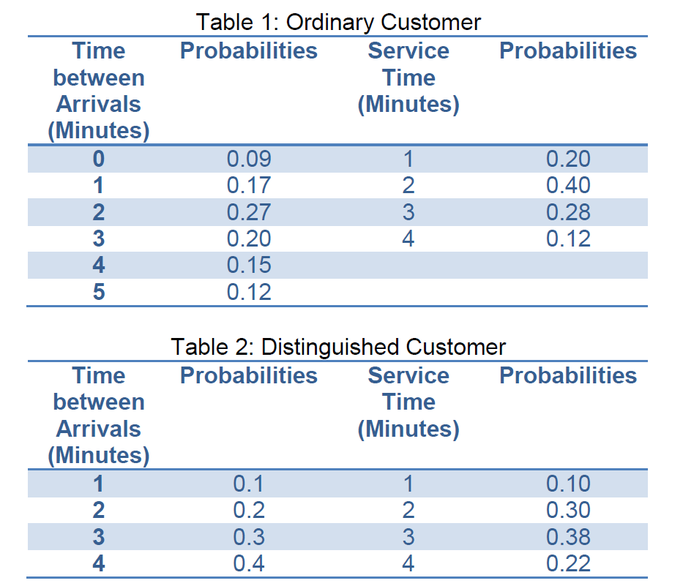

**System Analysis:**

Table of ordinary customers

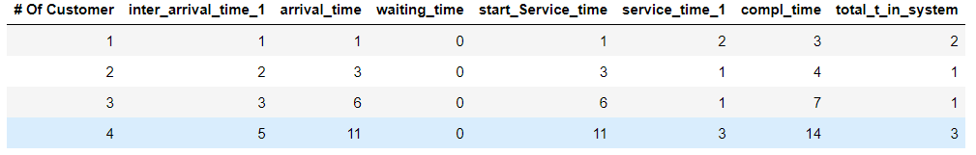

Table of distinguished customers

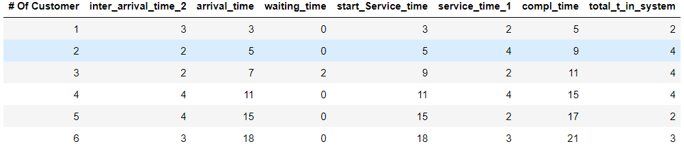

**Experimental Design Parameters :**

All of variables are uncontrollable (inter arrival time , service time ,type of customers)

probabilistic: this is the inputs which change through a probability distribution.(Inter arrival time, service time)

Controllable: this is the inputs which change through a manager.(no of tellers)